Lesson Focus: Geometry, Conversions, and Applied Engineering

Introduction: What is engineering? Making a big problem into small manageable parts that you can figure out, that is what critical thinking really is.

For my Externship project, I job shadowed and worked at BPM in Peshtigo and witnessed a lot of mathematics put to work, Here is a short clip of just a little bit of what BPM does: https://www.bpmpaper.com/Media_Channel.html

Here is a video showing an actual paper machine during production: https://www.youtube.com/watch?v=q7X4HaOSbc4

The paper on the paper machine runs continuously from when it leaves the headbox to when it is rolled onto the spool at the end of production. Therefore, everything must work at the same speed (or very close to the same speed, otherwise the paper will pull too tight and rip or create slack and create wrinkles in the paper). The paper at the BPM paper mill runs through the paper machine at approximately 200 ft/minute (faster when the paper is wet and slower as it dries and shrinks up slightly).
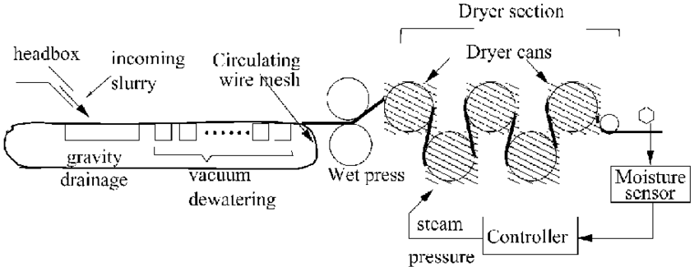

What we need to do is figure out at what speed in RPM’s (Revolutions/Minute) should we run our Dryer Cans to keep up with the speed of the paper through the machine.

Now for my lesson, today we will be going over circumference of a circle and conversions (unit conversions and ratio conversions for different sized gears)

Now that we know our situation, let’s get into the parts of the overall situation (How do we convert the speed of the paper into the RPM’s of the Dryer cans?). So how can we break down this problem? 1) Find the circumference of the cans and 2) use conversions to convert feet/minute into RPM.

So let’s investigate how we find the circumference of a circle (distance around the can):

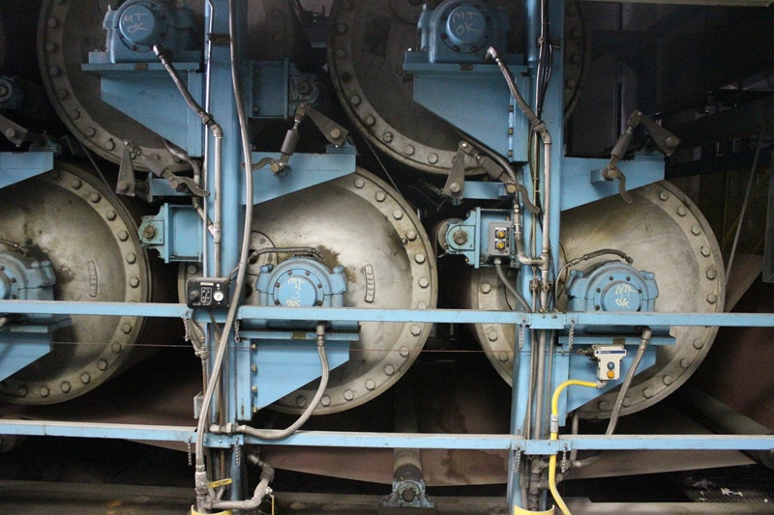
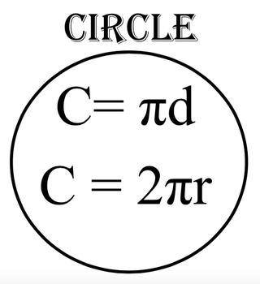

Circumference is the distance around a circle.

There are two synonymous formulas for the Circumference,
C = 𝝅d and C = 2𝝅r
And “r” is the radius
and “d” is the diameter
They are ultimately the same because 2*r = d

Example 1) if there is a 36” diameter Dryer Can, what is the circumference (find the circumference in feet and also find circumference in inches)?

So, to start off, which formula do you want to use? C = 𝝅d or C = 2𝝅r

I would use C = 𝝅d, since we know the diameter already C = 𝝅d
C = 𝝅3’ C = 𝝅36”
C = 9.42’ C = 113.10”

This means that the distance the paper goes in 1 revolution is 9.42 feet
Now that we know how to find the Circumference, let's do some conversions to take the overall production rate (speed of the paper and figure out how to find the revolutions per minute.

Let’s say for example, the Production Rate (how fast the paper moves on the machine) is 1500 feet/minute to convert this into revolutions per minute:

1500ft rev.
1 min. min

With conversions, we want to change the units by canceling them out using equivalent unit ratios (ex. 12”/1’ or 60 sec/1 min
So for the problem below we want to cancel out ft on top by putting a unit ratio of revolution over ft, as 1 revolution is 9.42 feet
1500ft 1 rev. 1500 ft * 1 rev. = 159.24 rev.
1 min. 9.42 ft 1 min * 9.42 ft = 1 min

Therefore, the 3’ drum would have to be rotating at 159.24 revolutions/1 minute
Practice: So let’s practice with a couple of real life examples: As I said before, one of the paper machines at BPM (called Big Ben) runs at approximately 200 ft/minute. The two main dryer cans sizes are 60-inch diameter and 48-inch diameter. Find the RPM of each of the dryer cans:
Quick question before we start: Which Dryer can should have a higher RPM the 60-inch dryer can or the 48 inch dryer can?

- Find the RPM of the 48” diameter Dryer Can.

- Find the RPM of the 60” diameter Dryer Can.

Were you correct with which Dryer can would have a larger RPM?

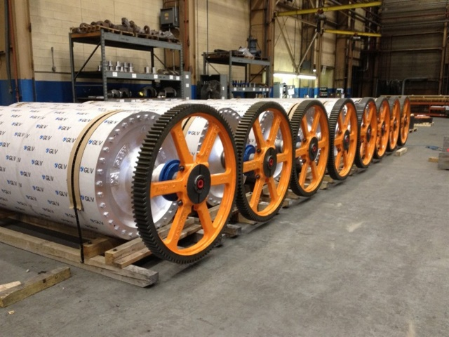
Now, there is more to the problem than just the RPM’s of the Dryer cans, as a variable speed motor controls the speed of the drum. And between the variable speed motor and the Dryer Can, there are multiple gears as well.

To the right is an example of a gear on the end of the
Dryer can. The gear at the end of the dryer can has
more teeth and the smaller gear, which pushes the
large gear has less teeth. These gears change the
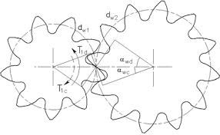
RPM’s of the shaft to make the motors’ job easier.
Just like when you pedal your bicycle up a hill, you
shift down to a lower gear to make it easier to get up
the hill. It does cause you to pedal more, but it also
makes pedaling easier.
Ok, now how are we going to use this? We need to do more conversions again.

So I want to start back at the example that I started off with (36” diameter dryer can). We had a speed of 159.24 Revolutions per Minute for the 36” diameter can. If the dryer can has a gear with 94 teeth and the gear that drives that has 26 teeth, how can we convert that through the gears on the shafts to figure out the RPM’s of the Motor?
We are going to start by working our way from the Dryer can to the motor: We want to figure out the Unit Ratios (between the number of teeth on the gear/1 revolution) and use them to convert the RPM of the Dryer Can into the RPM of the motor.

159.24 rev. 94 teeth 1 rev 159.24*94*1 rev = 14,968.56 = 575.71 rev
1 min 1 rev 26 teeth 1*1*26 min = 26 = 1 min

So the motor is really turning the shaft at 575.71 revolutions/minute.
*Think about the practicality of this: if you are pedaling your bicycle up a hill, you shift down to make it easier to pedal, but you need to pedal more to move the same distance. In this case, it is doing the exact same thing. The motor is able to turn these very large drums by gaining a mechanical advantage.
So let’s practice with a couple of real life examples: We previously found at what RPM the two main dryer cans sizes (60-inch diameter and 48-inch diameter) turn. Find the RPM of each of the motors that run each dryer can.
Quick question before we start: Should the shaft of the motor run at a higher or lower RPM as the shaft on the dryer can?
- Find the RPM of the motor that drives the 48” diameter Dryer Can when the gear at the end of the dryer can has 113 teeth and the gear that drives that gear has 40 teeth. (use the answer to #1 on the previous question)

- Find the RPM of the motor that drives the 60” diameter Dryer Can when the gear at the end of the dryer can has 118 teeth and the gear that drives that gear has 31 teeth. (use the answer to #2 on the previous question)

