For my Externship project, I job shadowed and worked at BPM in Peshtigo and witnessed a lot of mathematics put to work, Here is a short clip of just a little bit of what BPM does: https://www.bpmpaper.com/Media_Channel.html

Here is a video showing an actual paper machine during production: https://www.youtube.com/watch?v=q7X4HaOSbc4

Throughout the paper production, there is a lot of information that is tracked with each roll of paper made. Each roll is given a production number and with that number there is a bunch of data that is recorded and linked to that number (from the composition of the pulp, to weights, and much more as the production is completed). This allows BPM and other paper manufacturers to ensure consistency and quality control.
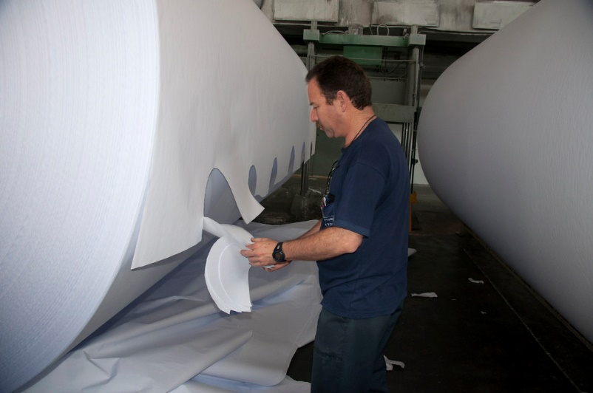
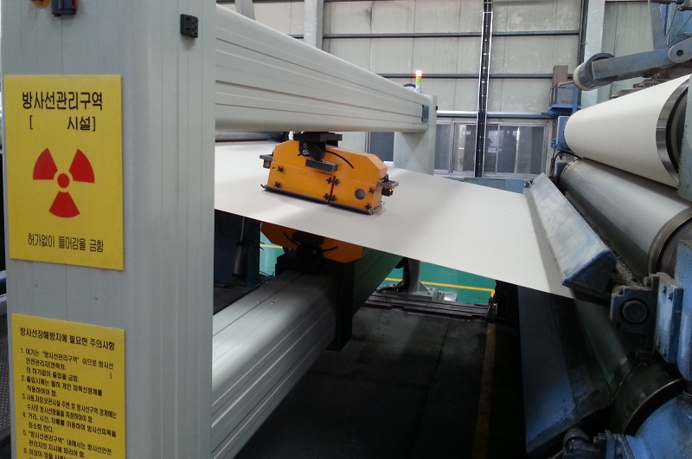

Image on the left is a Quality Control Scanner, and the image on the right shows someone taking a sample of each role of paper.

BPM uses both the scanners and systematic sampling of the paper rolls (they take a sample at the end of each roll).

For today’s lesson, we are going to take some data and try to figure out how we can measure the data, from finding it’s measures of Central Tendency and also work on measuring its variation.

Measures of Central Tendency: Mean, Median, and Mode (one number to describe the entire data set)

Mean: _______________________________________________________________________

____________________________________________________________________________

Median: _____________________________________________________________________

____________________________________________________________________________

Mode: _______________________________________________________________________

____________________________________________________________________________
Ex 1) Find the a) Mean, b) Median, and c) Mode of the following data set:

Heights of the Milwaukee Bucks Players:

6’-11”, 6’-10”, 6’-5”, 6’-4”, 6’-9”, 6’-5”, 6’-1”, 7’-0”, 6’-3”, 6’-7”, 7’-0”, 6’-4”, 6’-6”, 6’-7”

a) Find the Mean: (Add up all values and divide by the total number of data values)
Hint, let’s make everything into inches…as we can’t calculate when they are in 2 different units.

b) Find the Median of the Data set (List them in order from smallest to largest and then find the middle number)

c) Find the mode (the number that occurs most often)

Measures of Variation (one number that is used to describe how spread out the data is)

Interquartile Range: ____________________________________________________________

____________________________________________________________________________
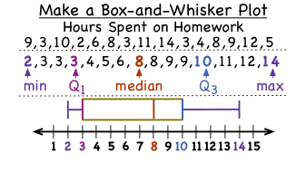
Q1: the __________________ of the bottom half. Sample

Q2: is the median

Q3: the __________________ of the top half

Ex 2) Find the IQR of the heights of the
Milwaukee Buck’s players.

Mean Absolute Deviation: _______________________________________________________

____________________________________________________________________________

Mean- is the average Deviation- is how far the values are away from the mean
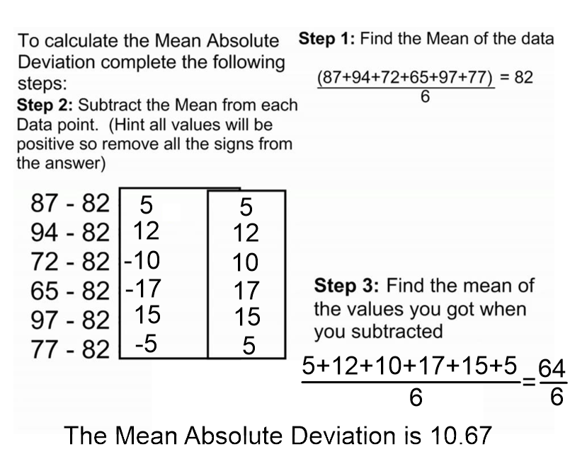
Absolute- means the distance is always positive (whether its 2 above or below, it is two away)

Ex 3) Find the Mean Absolute Deviation of the heights of the Milwaukee Buck’s

To Calculate the Mean Absolute Deviation, you will need to follow these 3 steps:

Step 1) Find the mean of the data set

Step 2) Find the difference between each data value and the mean (then take absolute value)

Step 3) Find the mean of each of the values you found in step #2

Now, let’s practice with some real life Problems:
- Mr. Malke was taking 1 square foot samples off the end of each paper roll. For this order, they were making a thicker paper (110 lb paper, which is used for the inserts in a magazine). So for this order, he measured each to get the following weights (in grams):
25.4, 28, 28.4, 26, 27.1, 28.1, 27.9, 27.7, 28
a) Find the Mean

b) Find the Mode
c) Find the Median

d) Find the IQR

e) Find the Mean Absolute Standard Deviation

If you wanted to describe how the data values vary, which measurements would you want to use, and why?

Now, let’s practice with some real life Problems:
- Mr. Malke was taking 1 square foot samples off the end of each paper roll. For this order, they were making a thinner (50 lb paper, which is used for copy paper). So for this order, he measured each to get the following weights (in grams):
14.7, 15.3, 15.4, 14.9, 15.6, 14.8, 15.3, 15.3, 15.9, 15.6
a) Find the Mean

b) Find the Mode
c) Find the Median

d) Find the IQR

e) Find the Mean Absolute Standard Deviation

- If you wanted to give one number which would represent the entire sample, what number would you choose?

- Do you think using the Mode to represent the whole data set works for this problem?

