Wisconsin Indians Basic Research

Name of Wisconsin Tribe: ________________________________________________________________
Put a star at approximately where tribe is currently located.
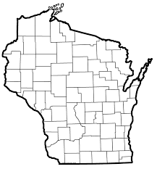

Was the tribe always located where it is now? If not, explain. ___________________________________

________________________________________________________________________________________

________________________________________________________________________________________

Approximately how many members does the tribe currently have? _____________________________

________________________________________________________________________________________

List the website(s) you used to find out about the tribe you were assigned or chose.

_________________________ _________________________ _________________________

_________________________ _________________________ _________________________

_________________________ _________________________ _________________________

_________________________ _________________________ _________________________

What other kinds of information would you like to learn about the tribe your were assigned or chose?

________________________________________________________________________________________

________________________________________________________________________________________

________________________________________________________________________________________

________________________________________________________________________________________

