Introduction to Casting
Assessment
Name: ___________________________________ Class: __________
Answer the following questions.
- What is casting?

- Write 3 examples of casting of objects we use in our daily life.
  - ___________________
  - ___________________
  - ___________________

- What are the three advantages of Casting?
  - ___________________________________________________________

  - ___________________________________________________________

  - ____________________________________________________________

- Identify the parts of a Mold for sand casting.
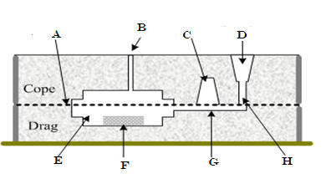
- ________________
- ________________
- ________________
- ________________
- ________________
- ________________
- ________________
- ________________

- Write six basic steps in Casting.
  - _______________________________________________________
  - _______________________________________________________
  - _______________________________________________________
  - _______________________________________________________
  - _______________________________________________________
  - _______________________________________________________

