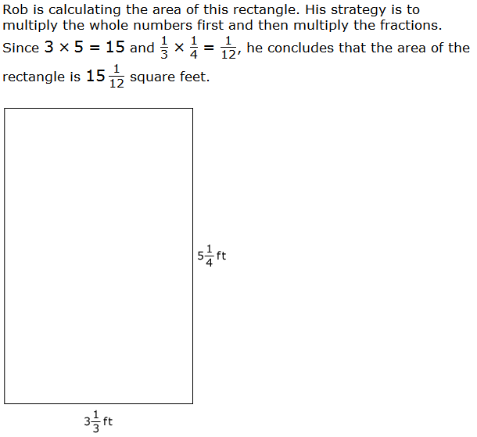
Teacher notes:
Apply and extend previous understandings of multiplication to multiply a fraction or whole number by a fraction.
B. Find the area of a rectangle with fractional side lengths by tiling it with unit squares of the appropriate unit fraction side lengths, and show that the area is the same as would be found by multiplying the side lengths. Multiply fractional side lengths to find areas of rectangles, and represent fraction products as rectangular areas.

For this item, a full-credit response includes the correct area, 17 ½ square feet.

On the Smarter Balanced Assessment task, students will need to be able to click on a key pad to enter the correct formula to find the area and the answer. Students can also click on a notes section if they wish to solve their work on the computer.

Not yet: Student shows evidence of misunderstanding, incorrect concept or procedure | Got It: Student essentially understands the target concept.
0 Unsatisfactory:  Little Accomplishment  The task is attempted and some mathematical effort is made. There may be fragments of accomplishment but little or no success. Further teaching is required. | 1 Marginal:  Partial Accomplishment  Part of the task is accomplished, but there is lack of evidence of understanding or evidence of not understanding. Further teaching is required. | 2 Proficient:  Substantial Accomplishment  Student could work to full accomplishment with minimal feedback from teacher. Errors are minor. Teacher is confident that understanding is adequate to accomplish the objective with minimal assistance. | 3 Excellent:  Full Accomplishment  Strategy and execution meet the content, process, and qualitative demands of the task or concept. Student can communicate ideas. May have minor errors that do not impact the mathematics.
Adapted from Van de Walle, J. (2004) Elementary and Middle School Mathematics: Teaching Developmentally. Boston: Pearson Education, 65

