Public Health Learning Activities
- Pre and post assessment: Ask students to write on paper their responses to the following:
  - What is public health?
  - Do we have a local department of public health?
  - What does that department do?
  - Who benefits from public health departments?
- Read lecture notes and view the embedded videos.
- Technology activity #1
  - Divide students into pairs. Have students access the Wisconsin Department of Health Services, Division of Public Health website. Assign each set one or two programs to explore and explain to the class. OR
  - Teacher select a 2 or 3 programs to explore with the students. Have students work in groups of two or three to create scenarios of individuals or groups of people who would benefit from the programs and services explored.
- Technology activity #2
  - Divide students into pairs. Assign each set one or two public health professions to explore and explain to the class. OR
  - Teacher select a 2 or 3 careers to explore with the students. Have students work in groups of two or three to discuss who in the class would be good in those professions and why, or to discuss what they like about the career and what they would like to know about.
- Technology activity #3
  - Students may be in pairs or alone to play The Great Flu located at http://www.thegreatflu.com/
- Technology activity #4
  - Students may be in pairs or alone to play Outbreak at Watersedge located at http://www.mclph.umn.edu/watersedge/
- Invite a public health nurse or other professional to the class to provide a 20 minute overview of the local public health department and 10 minutes of questions and answers.
- Post assessment

Introduction to Epidemiology
https://www.cdc.gov/careerpaths/k12teacherroadmap/epidemiology.html

Epidemiology is the study of methods or approaches used to find the causes and other characteristics of diseases. Epidemiology is the study of the distribution (frequency, pattern) and determinants (causes, risk factors) of health-related states and events (not just diseases) in specified populations (neighborhood, school, city, state, country, global).
It is also the application of this study to the control of health problems.
As an example, when there is an outbreak of measles as an example, the number of patients, locations of their homes, where they work or go to school are monitored. The information is shared with others in their workplaces or schools, local physicians and other health care professionals so that everyone can work together to isolate the outbreak which means to prevent or minimize the spread of the disease to others in the community. If we don’t do this, what will happen?

Who are epidemiologists?
When disease outbreaks such as measles or flu emerge, epidemiologists those professionals who are on the scene to investigate. Often called “Disease Detectives”, epidemiologists search for the cause of disease, identify people who are at risk, determine how to control or stop the spread or prevent it from happening again. Physicians, veterinarians, scientists, and other health professionals often train to be “Disease Detectives”. They receive additional education to become epidemiologists, generally a master’s degree in public health or specifically in epidemiology.

What do epidemiologists do?
Like investigators at the scene of a crime, disease detectives begin by looking for clues. They systematically gather information, asking questions such as:
- Who is sick?
- What are their symptoms?
- When did they get sick?
- Where could they have been exposed?
- Epidemiologists study answers to these questions to find out how a particular health problem was introduced.

Disease detectives use what they learn during the investigation and make recommendations to control the spread or prevent a future occurrence.

Wisconsin is one of 35 states that has an Epidemic Intelligence Service (EIS). When outbreaks happen that threaten the public’s health, elite disease detectives from CDC’s Epidemic Intelligence Service (EIS) External Link are on the scene.
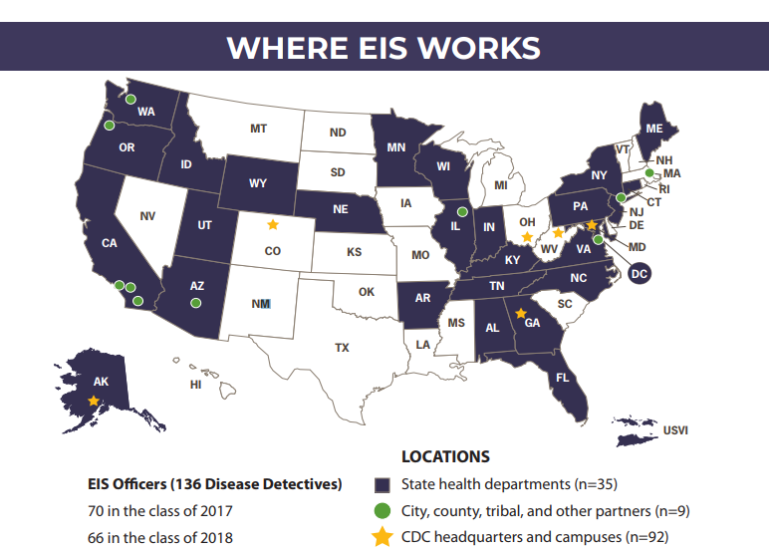

What is Public Health?

Watch: This Is Public Health (3 minutes) https://www.youtube.com/watch?v=oQkGx6gRGIY

Public health promotes and protects the health of people and the communities where they live, learn, work and play.

While a doctor treats people who are sick, those working in public health try to prevent people from getting sick or injured in the first place. Public health professionals also promote wellness by encouraging healthy behaviors.

From conducting scientific research to educating about health, people in the field of public health work to assure the conditions in which people can be healthy. That can mean vaccinating children and adults to prevent the spread of disease. Or educating people about the risks of alcohol and tobacco. Public health sets safety standards to protect workers and develops school nutrition programs to ensure kids have access to healthy food.

Public health works to track disease outbreaks, prevent injuries and shed light on why some of us are more likely to suffer from poor health than others. The many facets of public health include speaking out for laws that promote smoke-free indoor air and seatbelts, spreading the word about ways to stay healthy and giving science-based solutions to problems.

Public health saves money, improves our quality of life, helps children thrive and reduces human suffering.

Watch: What Is Public Health? (3minutes 7 seconds): https://www.youtube.com/watch?time_continue=26&v=XkSnp9jQYSc
Students work in pairs or groups to create their own definition of public health and share with the class. Teacher facilitates the creation of a collaborative definition reflecting the work of the students.

Complete Technology activity #1

Careers in Public Health

Watch: A Public Health Career for a Lifetime (6 minutes 12 seconds) https://www.youtube.com/watch?v=F_P8lCzm2Ao

Some examples of the many professionals working in public health are listed here. Students offer their perspectives of what each do.
- First responders
- Restaurant inspectors
- Health educators
- Scientists and researchers
- Nutritionists
- Community planners
- Social workers
- Epidemiologists
- Public health physicians
- Public health nurses
- Occupational health and safety professionals
- Public policymakers
- Sanitarians

Credit for the above information is given to the American Public Health Association https://www.apha.org/what-is-public-health

Watch: Public Health Career Paths: EIS — The Nurse (4 minutes 40 seconds) https://www.youtube.com/watch?v=G2G8ipXU67s

Students as a class, in pairs, or in small groups discuss how the role of a public health nurse differs from what they know about the typical work of a Registered Nurse.

Complete Technology activity #2.

The Centers for Disease Control and Prevention (CDC)

Watch: CDC 24/7 Saving Lives, Protecting People (2 minutes 43 seconds) https://www.youtube.com/watch?v=nA1-0q4pza0

CDC IS OUR NATION'S PREMIER PUBLIC HEALTH AGENCY.
The Centers for Disease Control and Prevention (CDC) is the nation’s leading public health agency, dedicated to saving lives and protecting the health of Americans. CDC keeps America secure by controlling disease outbreaks; making sure food and water are safe; helping people avoid leading causes of death such as heart disease, cancer, stroke and diabetes; and working globally to reduce threats to the nation’s health. When a national health security threat appears, CDC may not know right away why or how many people are affected, but the agency has world-class expertise to find out what is making people sick and what to do about it.
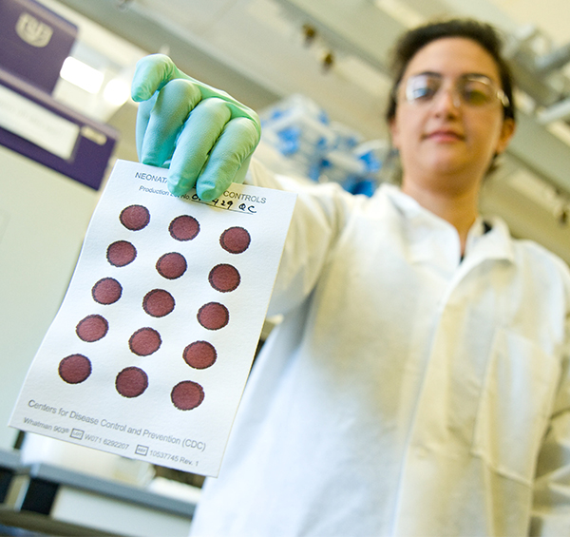
CDC is ready 24/7 to respond to any natural or manmade event. By connecting state and local health departments across the nation, CDC can discover patterns of disease and respond when needed. CDC monitors health, informs decision-makers, and provides people with information so they can take responsibility for their own health. CDC also trains and guides state and local public health laboratory partners to ensure that labs can safely detect and respond to dangerous health threats.
CDC works to strengthen local and state public health departments and promote proven health programs. Headquartered in Atlanta, CDC has a staff of more than 14,000 employees in nearly 170 occupations who work in all 50 states and more than 50 countries.
Credit for the above information is given to the CDC Foundation https://www.cdcfoundation.org/what-public-health

The Wisconsin Department of Health Services includes the Division of Public Health. In our state, this division ensures the areas where people live, work and play are safe and free from environmental hazards. Some of the programs included in our Department of Public Health are:
- Clean Water
- Dementia Services
- Immunization
- Maternal and Child Health
- Oral Health
- Environmental Health
- Disease Prevention and surveillance
- Physical Activity and Nutrition
- Health Emergency Preparedness
- Services for Older Adults
- Flood Recovery
- Vital Records
- WIC program
- Tobacco Prevention
- Opioid Response

Click on https://www.dhs.wisconsin.gov/dph/index.htm to see what each covers or select a small number to discuss.

Post assessment

Class discussion begins in small groups identifying what students knew before the lesson plan and what they learned.
Class discussion continues with their view of science, health care, and public health as career options.

