Cell Phones from the Past
Directions: Use the cell-phone screens below to illustrate the life of a character from Romeo & Juliet. EVERYTHING you place below should reflect your chosen character and his or her life. AVOID GENERALIZATIONS- You customize your cell phones; now think, how would they do the same? Follow the guidelines listed below, and use the back for more space:
- Contacts: list at least 4 characters they’d have on “speed dial”
- Text messages: write 3-4 text message conversations they’d have with other characters
- Last Snap received: Draw out 1 detailed image of the last Snapchat image received by your character
- Facebook status: Write out 3 of the character’s last Facebook statuses, in relation to events in the story
- Center screen: draw out what you think their “home” or “background” screen would have looked like
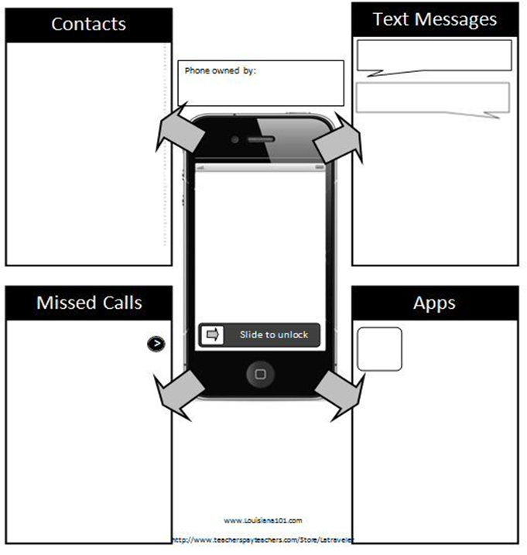
Last Snap Received
Facebook Status

