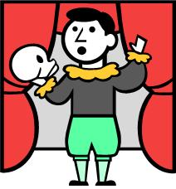
Frozen Dramatic Pictures: Instructions
- Read through your group’s section of the prologue and determine the meaning of each individual word, as well as the overall meaning as well. Use a dictionary, context clues, and each other to determine meaning.
- Rehearse a performance of your card's lines that includes reading chorally or individually, physically expressing the words through movement and gestures, and showing the meaning of your lines of text in at least one frozen dramatic picture that will end your section of text. The more gesture and emotion in your performance, the easier it will be for students to understand your text’s meaning.
- After rehearsing, perform your group’s part of the prologue in front of the class in sequential order.
- Be ready to explain your group’s section of text with the class when finished.

Frozen Dramatic Pictures: Instructions
- Read through your group’s section of the prologue and determine the meaning of each individual word, as well as the overall meaning as well. Use a dictionary, context clues, and each other to determine meaning.
- Rehearse a performance of your card's lines that includes reading chorally or individually, physically expressing the words through movement and gestures, and showing the meaning of your lines of text in at least one frozen dramatic picture that will end your section of text. The more gesture and emotion in your performance, the easier it will be for students to understand your text’s meaning.
- After rehearsing, perform your group’s part of the prologue in front of the class in sequential order.
- Be ready to explain your group’s section of text with the class when finished.

