**A B C D E F G H I J K L M N O P Q R S T U V W X Y Z**

**Keyboard Fingerings**

**Name: _______________________________________ Fingerings_______/_26_**

**Please write which keys are struck with each finger on both hands.**

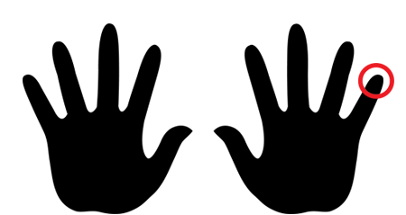

**Left**

**Hand**

**Keys**



**Right**

**Hand**

**Keys**

**Keyboard Fingerings**

**Name: _______________________________________ Fingerings_______/_26_**

**Please write which keys are struck with each finger on both hands.**

**A B C D E F G H I J K L M N O P Q R S T U V W X Y Z**



**Right**

**Hand**

**Keys**



**Left**

**Hand**

**Keys**