NAME:_____________________ HOUR:______________ GRADE:____/14 points

Label the particles on the left as solid, liquid, or gas. Draw the particles after a phase change on the right. (1pt for drawing)
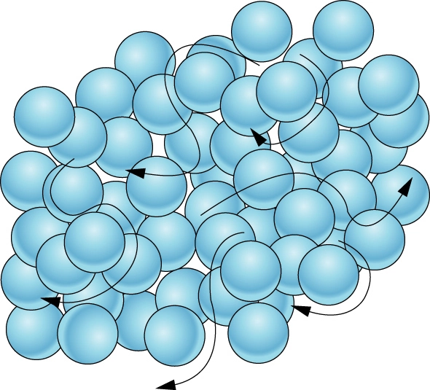

Phase Change (1pt):
Freezing
Evaporating
Melting
Vaporizing
Subliming
Condensing
Is the picture above a Solid, Liquid, or Gas? Circle (1 pt) Is the picture above a Solid, Liquid, or Gas? Circle (1 pt)

Describe the particles on the left |  | Describe the change on the right
Energy
(2pts)
Speed
(2pts)
Distance
(2pts)

Use a minimum of two vocabulary words (from your notebook) to describe a mistake that could have been made during the particle dance. Use particles to describe, what they were doing wrong? Use particles to describe, what they should have done? Describe the particles in detail. (4 pts)

___________________________________________________________________________________________________________________________________________________________________________________________________________________________________________________________________________________________________________________________________________________________________________________________________________________________________________________________________________________________________________________________________________________________________________________________________________________________________________________________________________________________________________________________________________________________________________________________________________________________

