**Trigonometric Ratios Activity**

**Learning Target:**

**Trigonometry:**

A ratio of the lengths of two sides of a right triangle is called a trigonometric ratio.

Sine:  Cosine:  Tangent: 

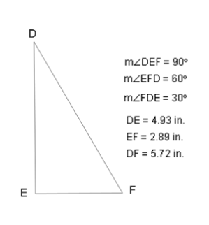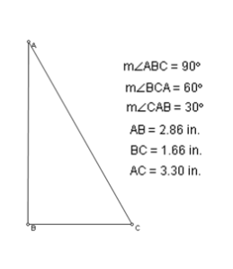

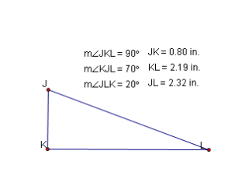

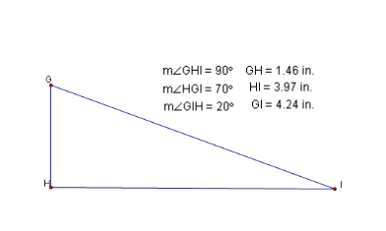

1. Complete the chart using the triangles. Round answers to the nearest ten thousandths.

|  |  |  |  |
| --- | --- | --- | --- |
| Angle | Sine | Cosine | Tangent |
| ∠A = |  |  |  |
| ∠C = |  |  |  |
| ∠D = |  |  |  |
| ∠F = |  |  |  |
| ∠G = |  |  |  |
| ∠I = |  |  |  |
| ∠J = |  |  |  |
| ∠L = |  |  |  |

2) Use your calculator to find the following. Round answers to the nearest ten thousandths.

sin 60° = _______ cos 60° = _______ tan 60° = _______

sin 30° = _______ cos 30° = _______ tan 30° = _______

sin 70° = _______ cos 70° = _______ tan 70° = _______

sin 20° = _______ cos 20° = _______ tan 20° = _______

1. How are the sine and cosine values related for complementary angles? Use the handout “Values of Trigonometric Functions” along with your answers to #2 to answer this question.