**Special Right Triangles**

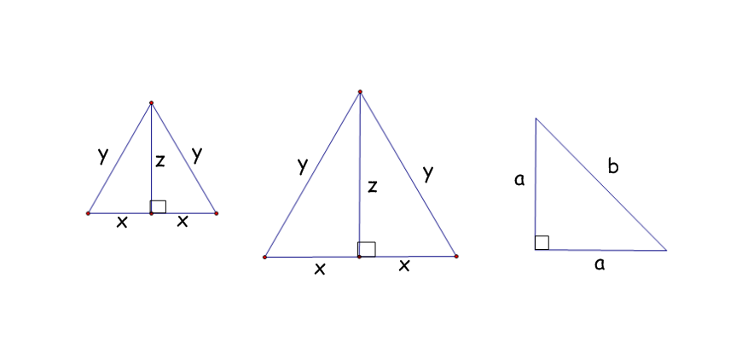**Learning Target:**

Two special kinds of **right triangles** are: 45°-45°-90° and 30°– 60° – 90°

1) Measure the angles, side lengths to the nearest tenth of a centimeter.

x = ______

y = ______

z = ______

x = ______

y = ______

z = ______

a = ______

b = ______

2) Describe the triangles formed by the altitudes.

3) Find the following ratios for each triangle:

   

4) Compare the ratios from #3. Are the results similar for any of your triangles?

5) Use your calculator to find  _________ and __________

Draw a picture of both triangles to demonstrate the formulas.

30°– 60° – 90° 45°-45°-90°

**Find the missing sides using your formulas.**

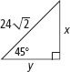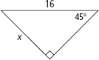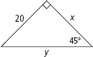

1) 2) 3)

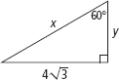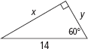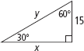

4) 5) 6)

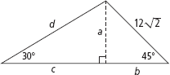7)